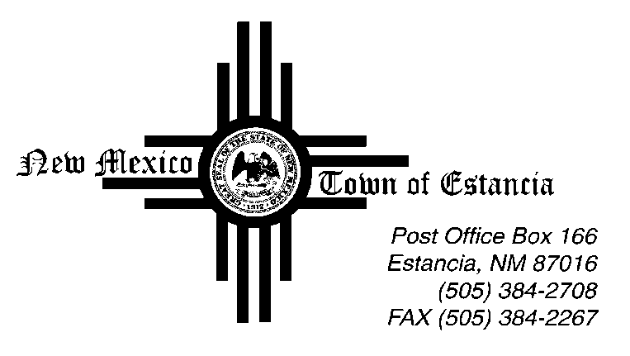

Mayor
Nathan Dial

Mayor Pro Tem
Noah Sedillo

Trustees
Morrow Hall
Stella Chavez
Albert Lovato

____________________________________________________________________________________________

Notice of Possible Quorum

04.12.2022

This Public Notice is being posted to inform the public that there will be a Possible Quorum of some Board of Trustees on Friday, April 12, 2022 in the Town of Estancia.

The Possible Quorum will be strictly for the purpose of meeting with Congresswoman Stansbury to discuss possible Federal Funding for Town projects. No action will be taken, and no further business will be conducted.

